**CS590BD Big Data Analytics and Applications**

**Lab 1 Assignment- Task 2 & 3**

**By**

**Kommineni Siva Krishna**

**Task 2: Cloudera.**

**Subtask 1:** How to access UMKC Cloudera Servers

1. Accessing UMKC Cloudera Individual Server

Login to the following url <http://134.193.136.127:7180>

You must be in UMKC network inorder to acess it. Other wise you must install UMKC VPN for acess.

Enter your SSO ID as username and password

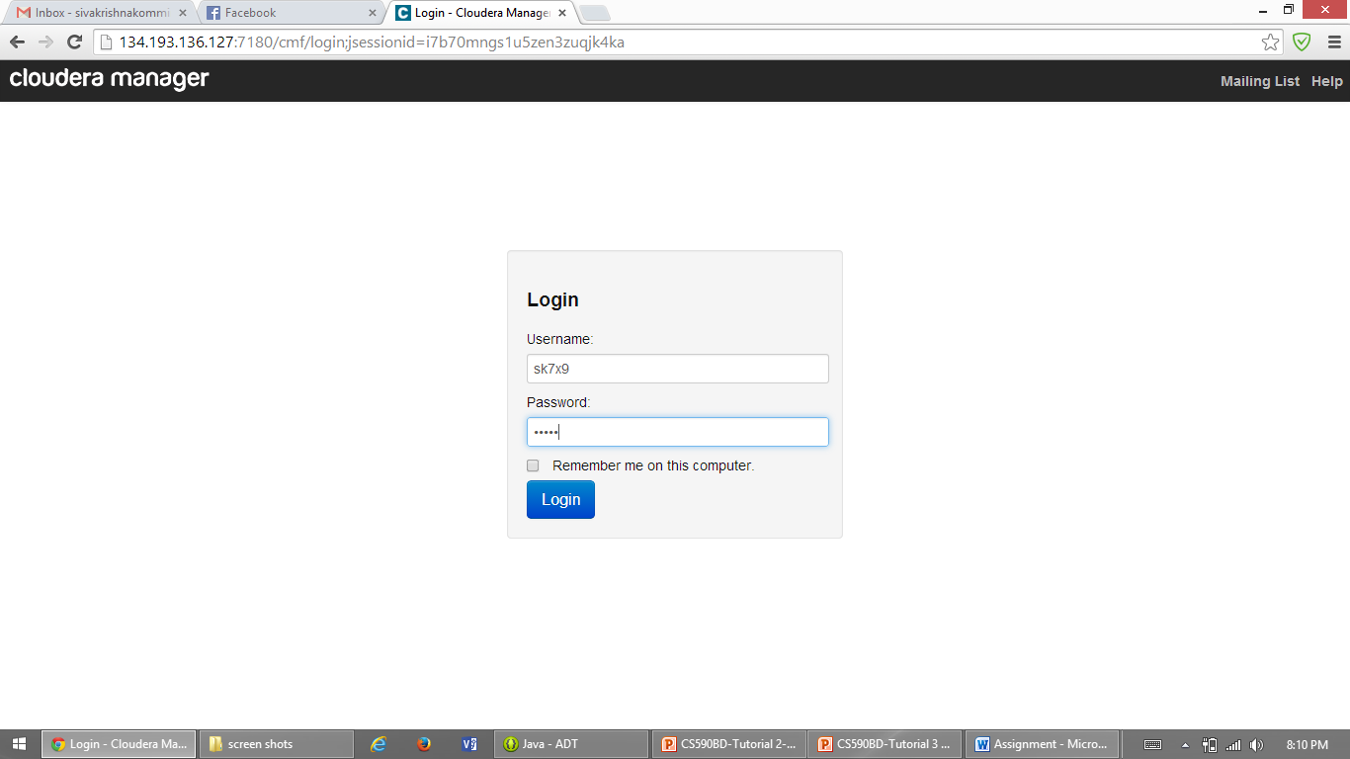

After entering the SSO ID as credentials you will be directed to the UMKC individual Cloudera server as follows.

It shows the status of all the services available in the server.

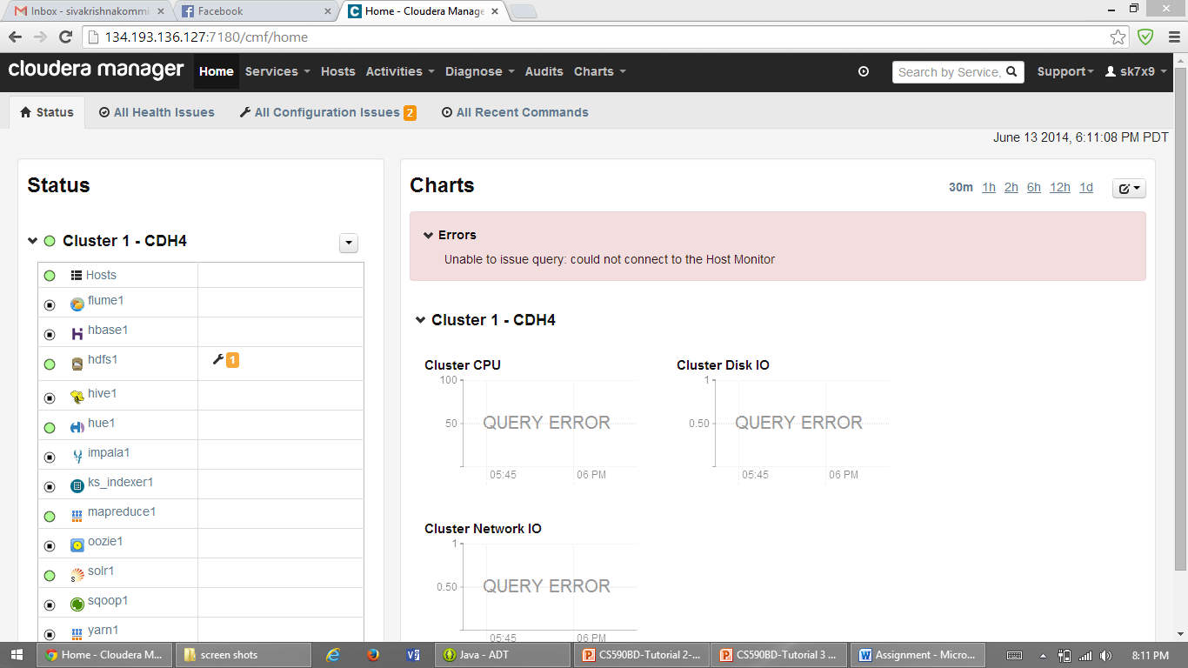

1. Accessing UMKC Cloudera Group Account Server

Group Account servers can be accessed by downloading and installing Putty from the below url

<http://www.chiark.greenend.org.uk/~sgtatham/putty/download.html>

Then enter the host name as shown below and press open.

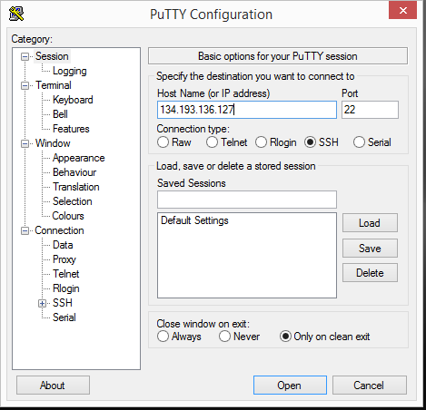

After connecting it will be redirected to the following window.

Login as group2

Both the username and password are the group2.

You can any time change your password if required.

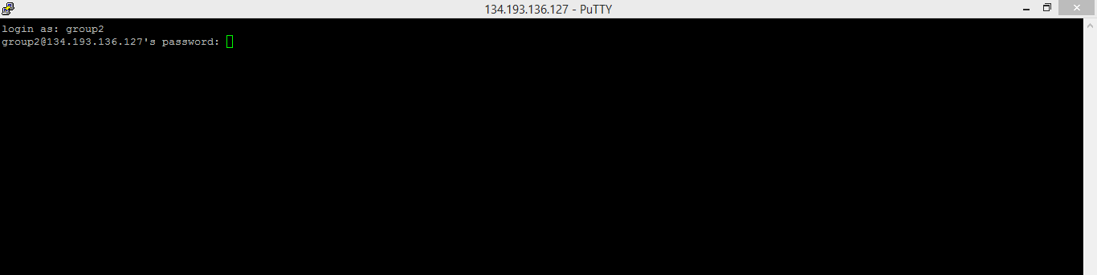

**Subtask 2:** How to install your own Cloudera Server

Firstly Download the Cloudera 4.5 image and the download the VM player 6 and then map the image that you have downloaded to the VM player.

* Download Cloudera image at <http://www.cloudera.com/content/support/en/downloads/download-components/download-products.html?productID=F6mO278Rvo>
* Download Vmware player at (<http://www.vmware.com/products/player>)

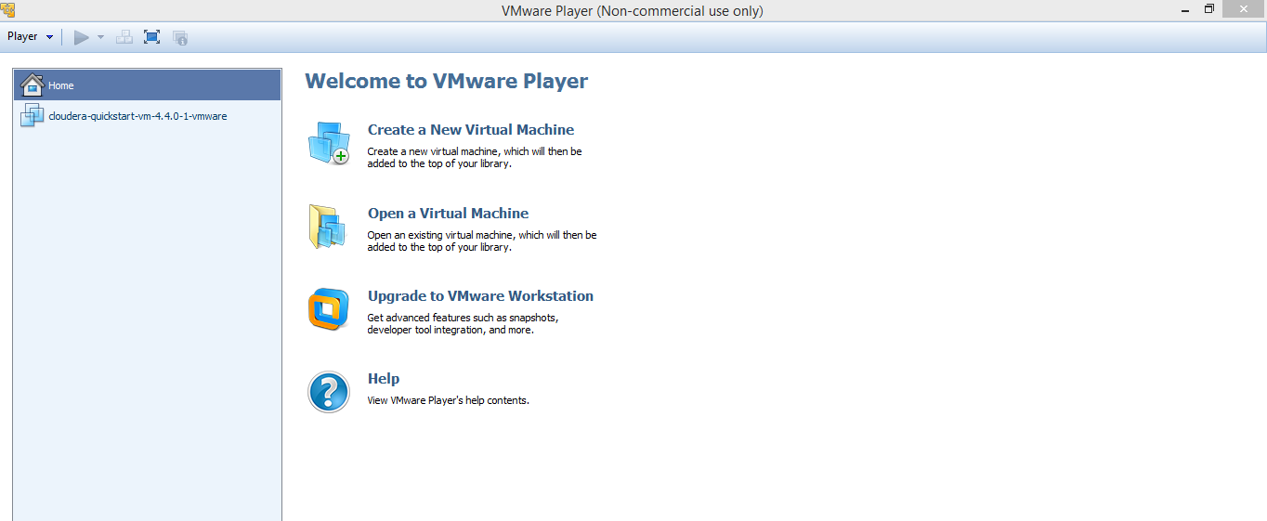

After mapping the downloaded image to the VM Player it shows to start the player as follows.

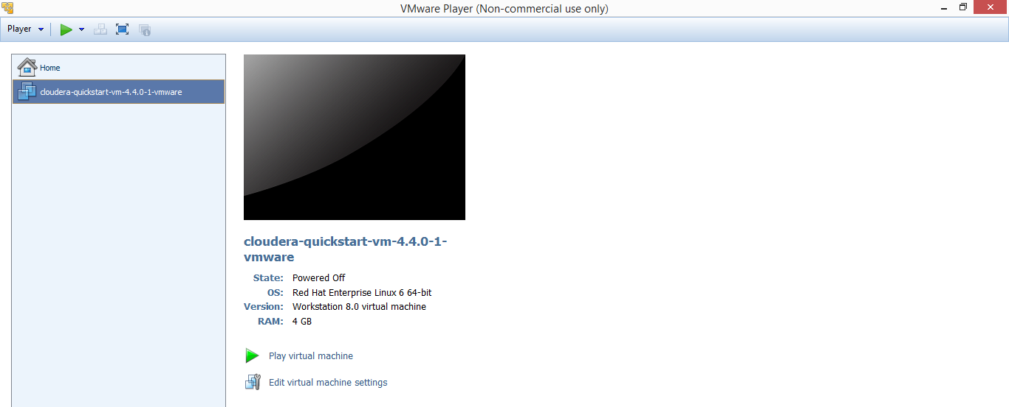

After the image gets opened login into the Cloudera Manager.

Both the username and password are - cloudera

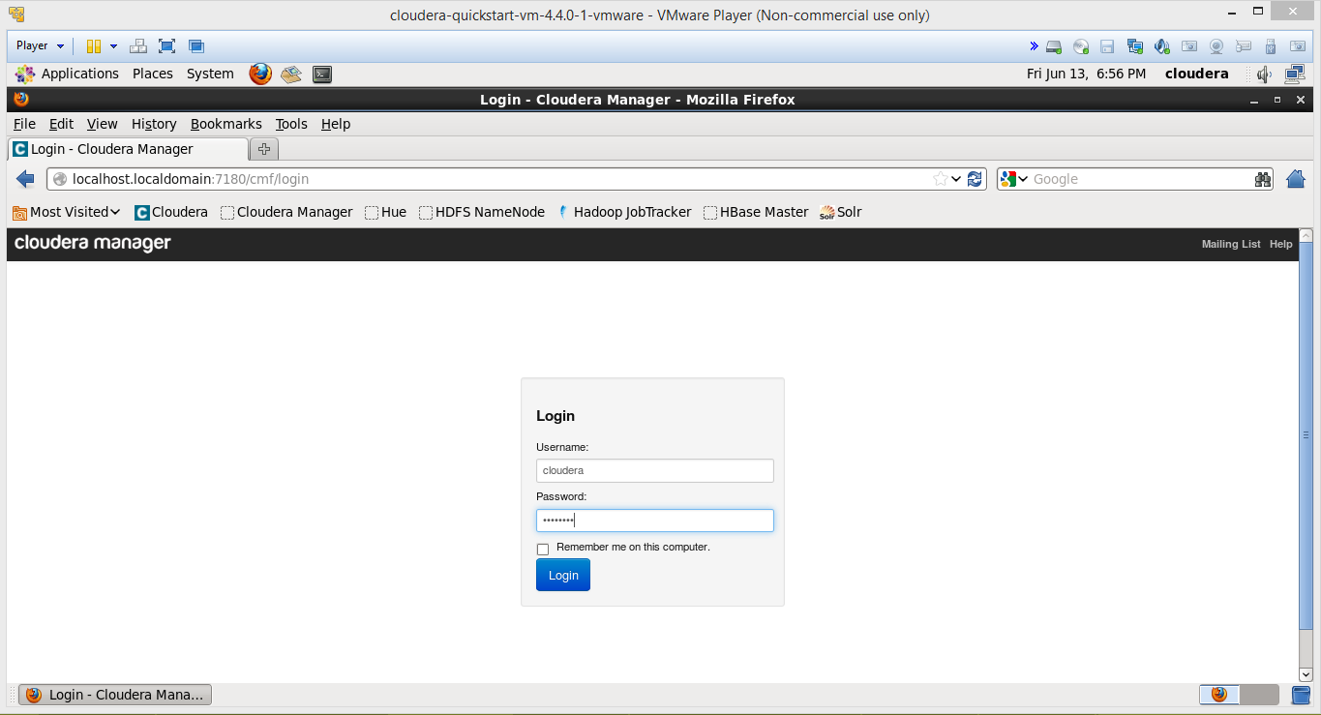

After entering the credentials it shows the all available services in the order as follows.

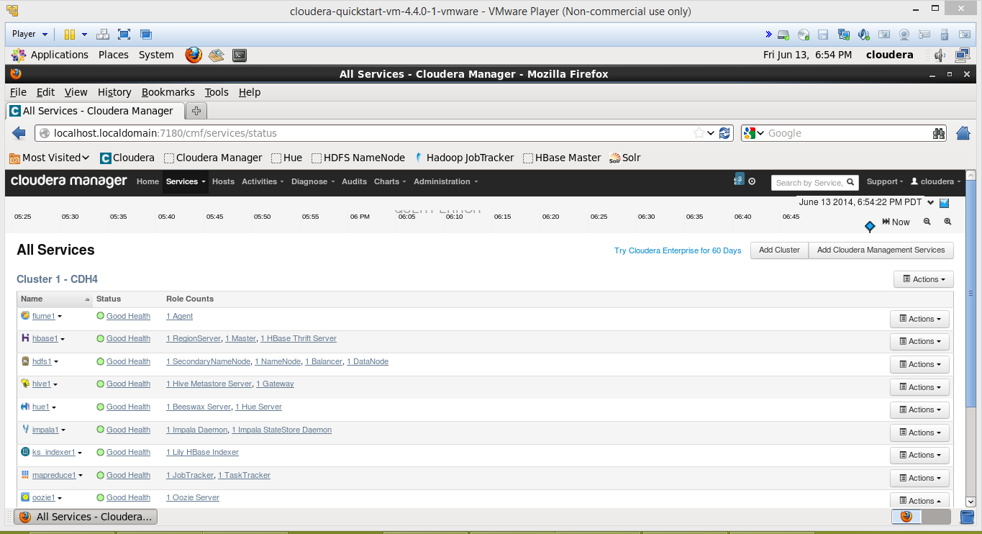

**Subtask 3:** How to transfer files to Cloudera

* WinSCP is a very easy way to transfer files remotely from win to linux
* <http://winscp.net/eng/download.php>

It can be downloaded from the above url

If we press Quick Connect it will show a pop-up for connection to the remote host.

Enter the host name and username as shown below and connect it.

Later a pop-up appears for password.

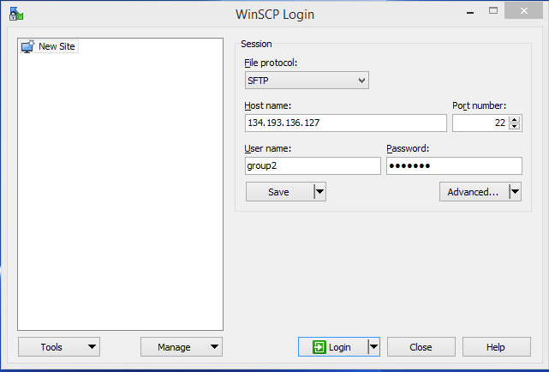

After entering the password it will be connected to the host as follows.

The username and password is group2.

Later you can transfer files directly using the file transfer window present in the top.

If we click on that icon it opens as follows.

It shows the both areas side by side

Just we need to drag and drop the files required from left window to right window.

It is easier way to transfer files.

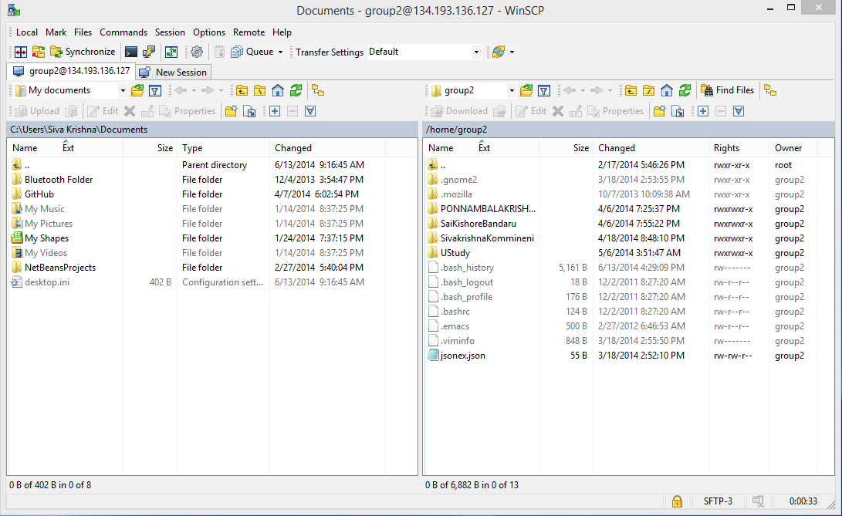

**Subtask 4:** How to run a Program “Word Count” on Cloudera

Download the WordCount example from the below url

<https://portal.futuregrid.org/manual/hadoop-wordcount>

After downloading it in the VM, unzip it as shown below by going to the Downloads folder

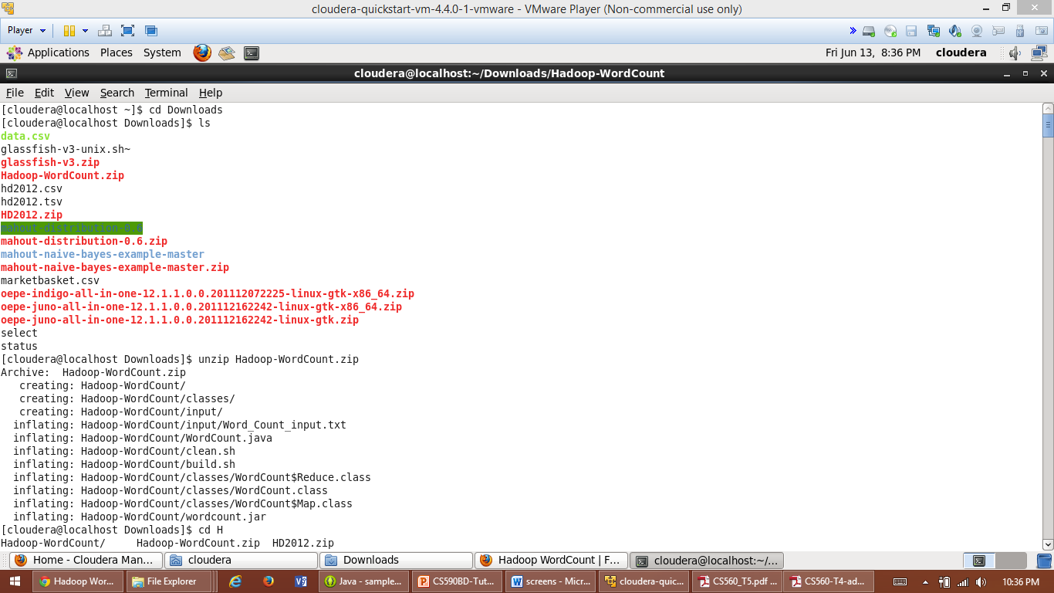

Run Later go to the WordCount Folder extracted and follow using hadoop commands.

put local input file to the hadoop input directory:

hadoop fs –put input input

Late run the below command

Run hadoop:

hadoop jar wordcount.jar WordCount input output3

Some MapReduce happens and then shows as follows after execution of the classes.

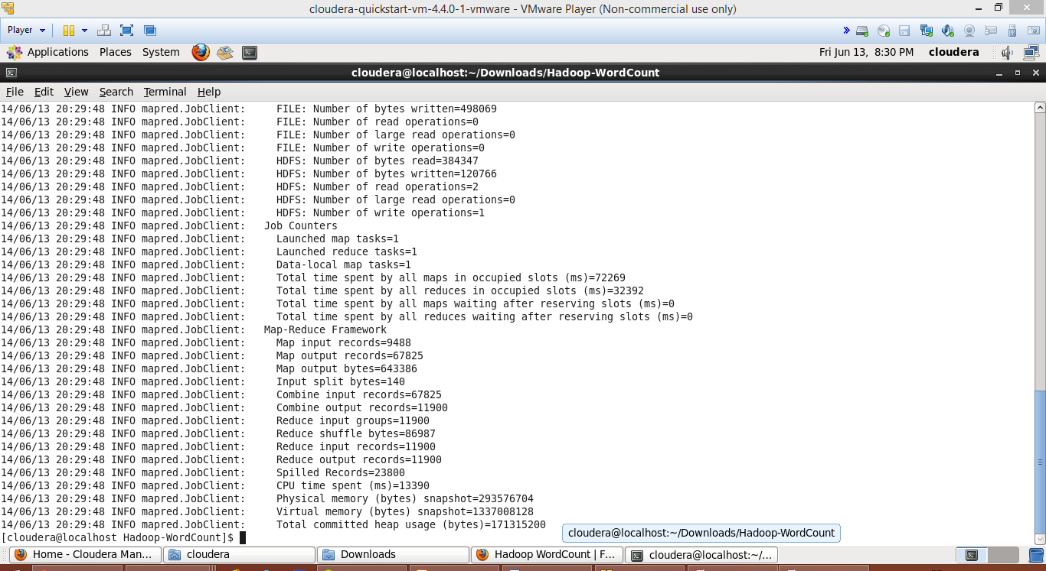

At last,enter the following command

hadoop fs -cat output3/*

Finally you will be able to see the results in the output file as follows.

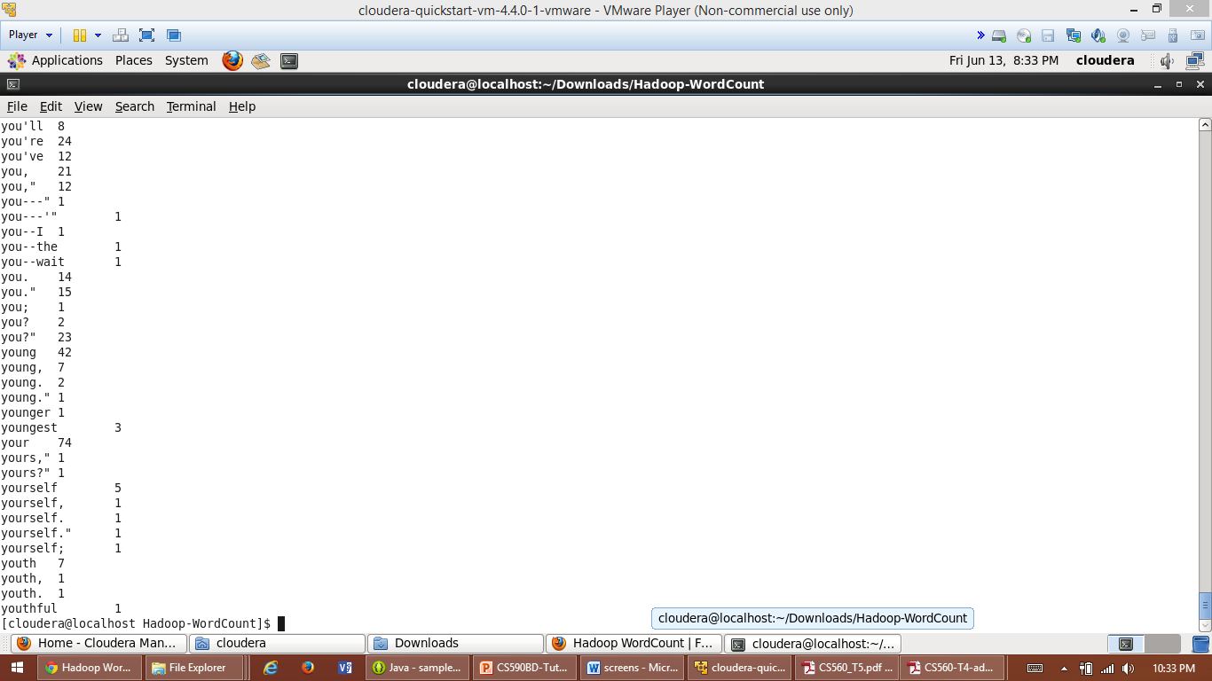

**Subtask 5:** How to make a hadoop jar and run it in Cloudera

First import the existing file system into eclipse as shown below.

You can see the WordCount folder structure.

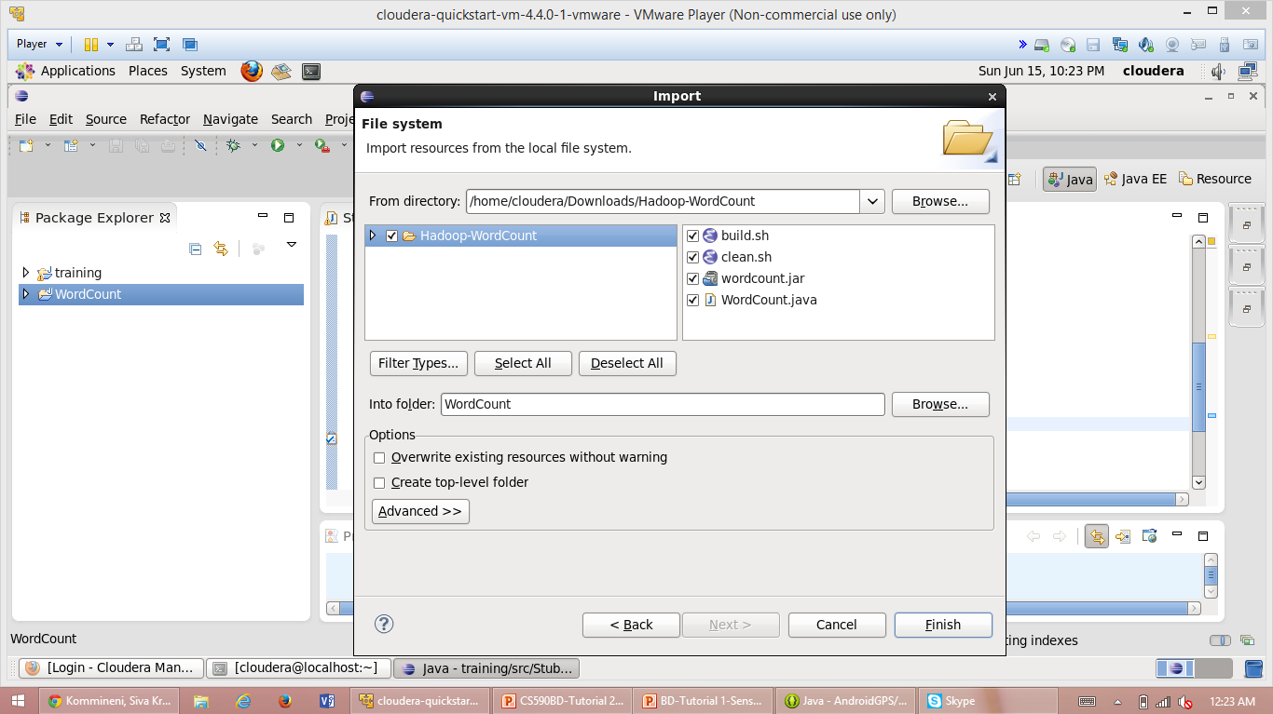

Later export the jar file of the project and run it on cloudera.

You can see the output after running this hadoop jar on cloudera.

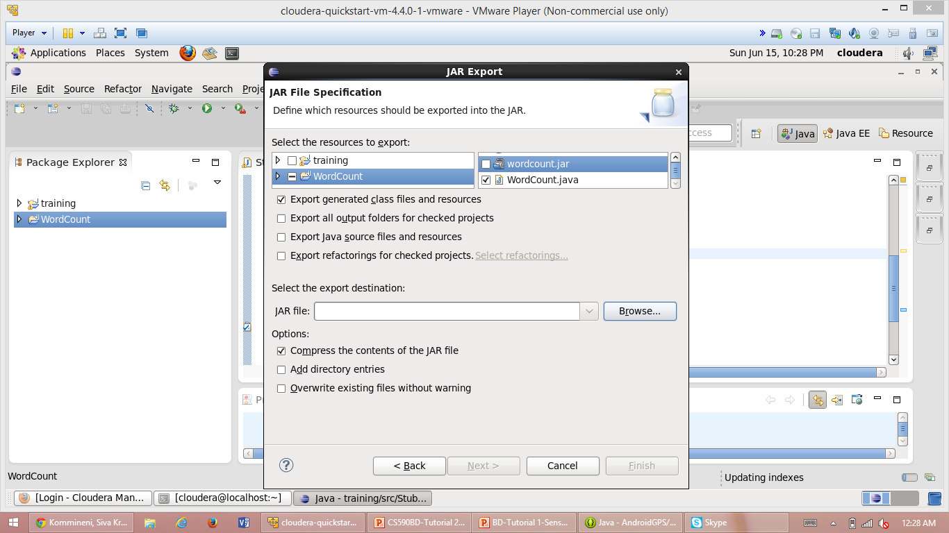

**Subtask 6:** How to Build a java based restful service in Cloudera

To build a rest ful web service we should first install the glassfish server in our eclipse and then proceed as follows.

After installing the glassfish you can see the glassfish server started in the console as shown below.

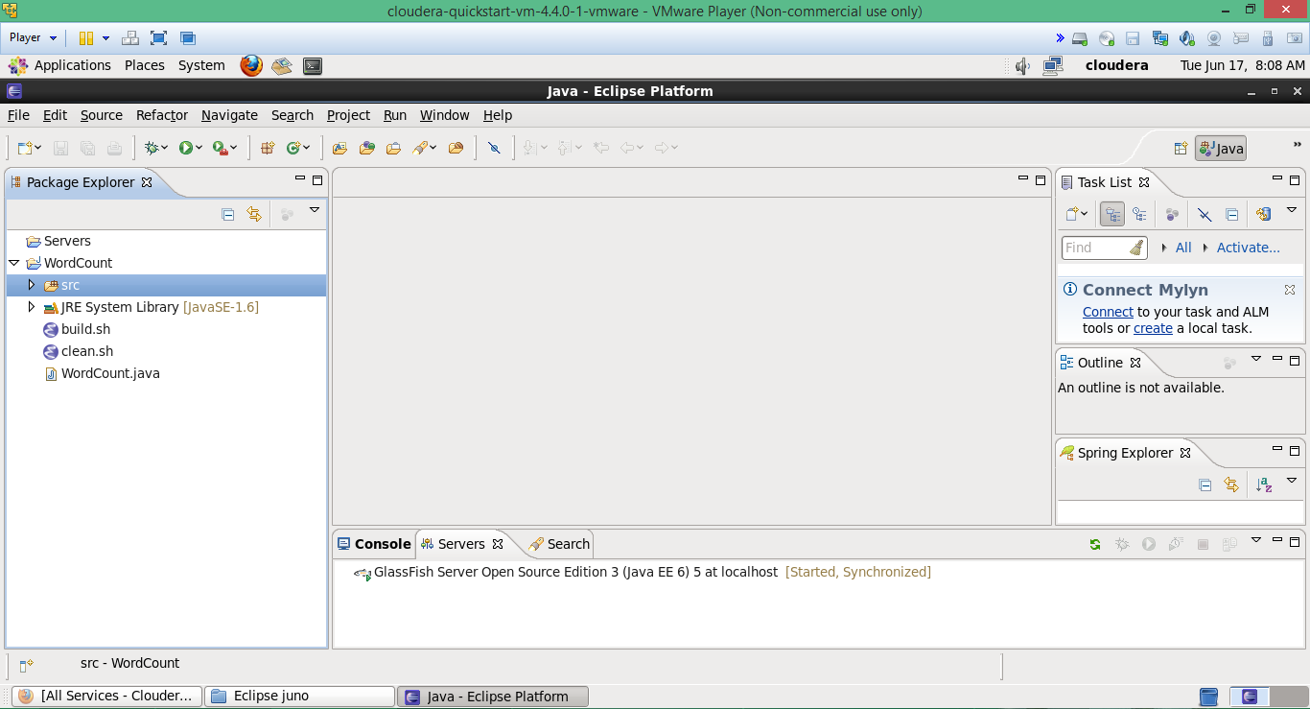

Next create a dynamic web project as shown below

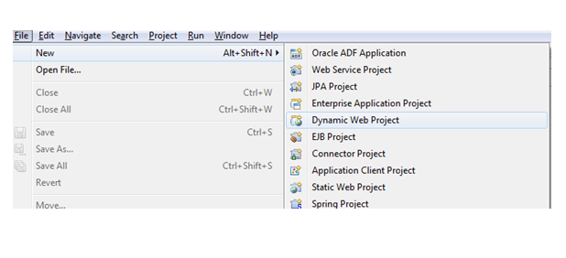

Conform the project and then you can create the services o the project as shown below.

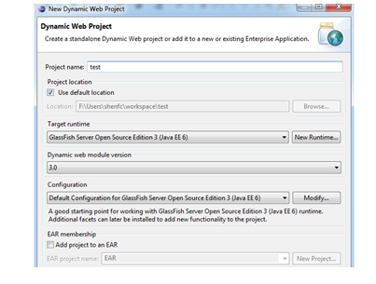

Create a restful web service to host it in cloudera so that we can access it any where.

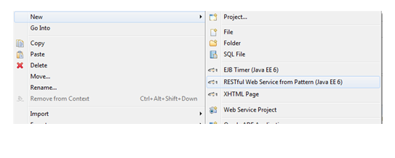

After successful creation of the webservice and the glassfish server installation you can see the glassfish in the web page as folllows.

You can deploy any application and services on this server so that you can access it anywhere.

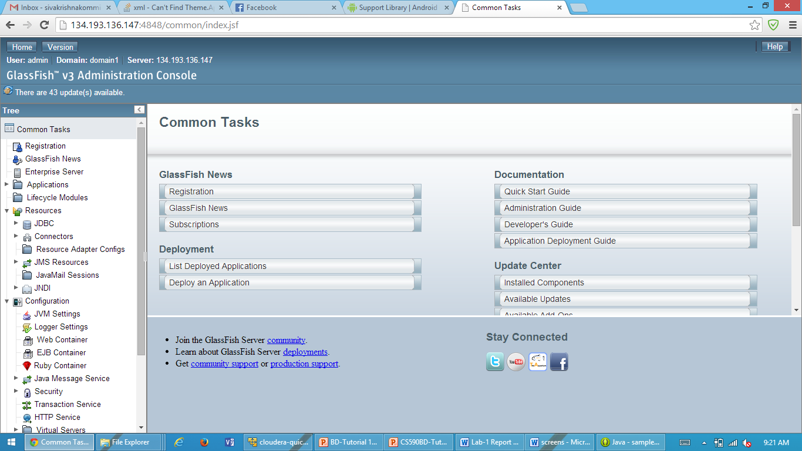

Now go to eclipse and create a war file and deploy the war file .

It shows the deployed application as below.

Now you can access the deployed application service and can check the result

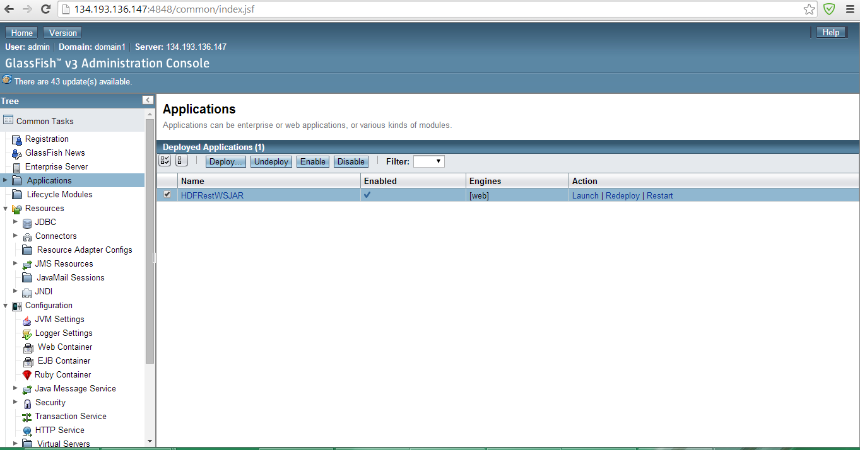

**Task 3:** Github and Scrumdo

**Subtask 1:** How to create an account and deploy files to Github

We can perform the following operations using Github and submit the files and synchronize the files and commit the changes .

1. Create Git remote repository using Git account

2. Install GitHub for windows, clone the remote repository to our local machine

3. Modify files at local machine, commit and synchronize with remote one

4. Team work, different members commit and synchronize work

First we need to sign up for GitHub using the following url:- <https://github.com>

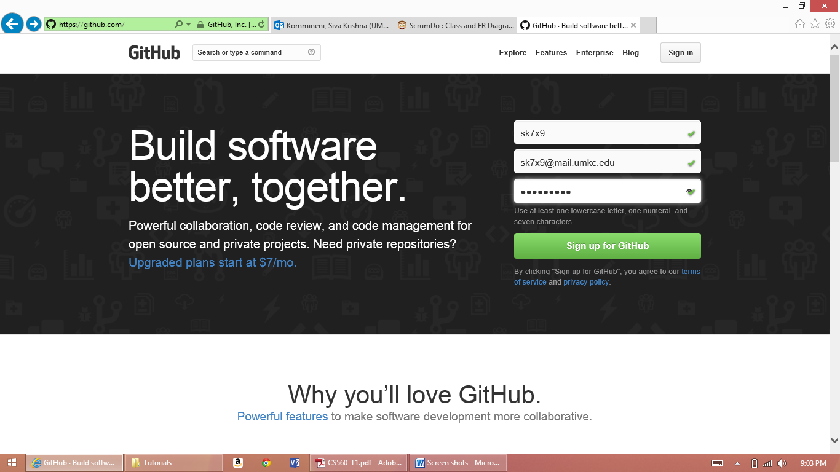

Then join GitHub by creating your own Password.

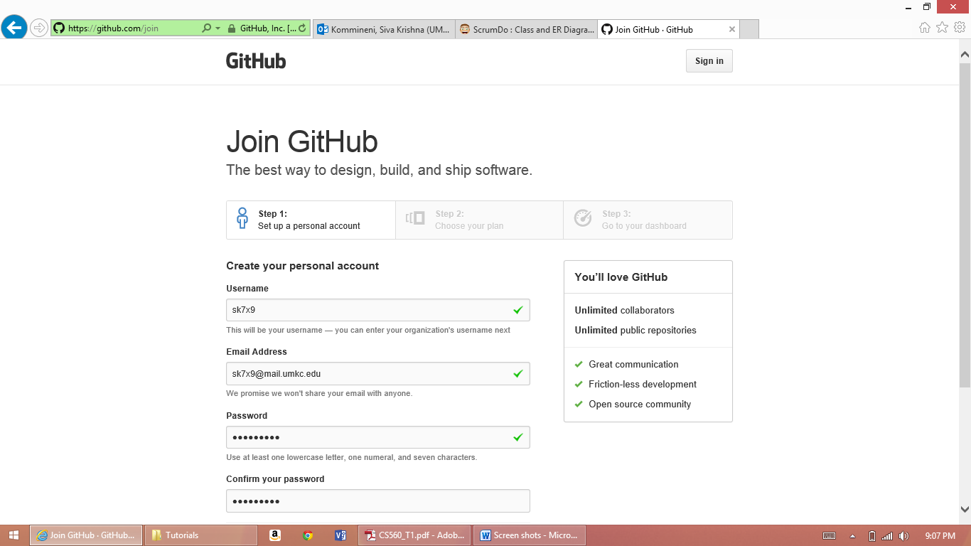

Clone Github then you can see the cloned repositories from desktop as follows.

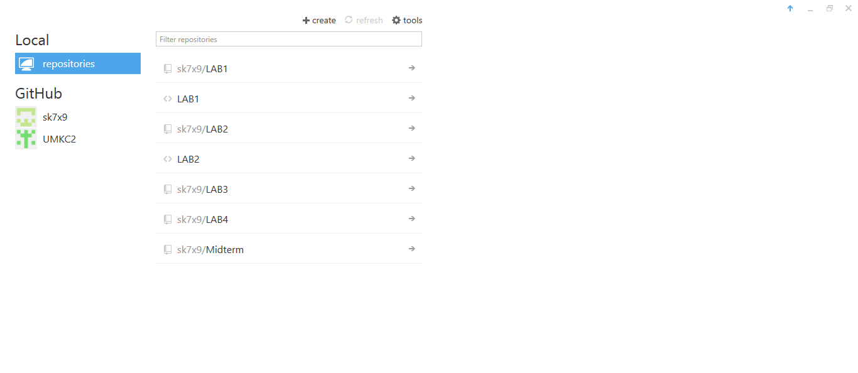

Github folder structure is formed under the following directory after cloning to the desktop.

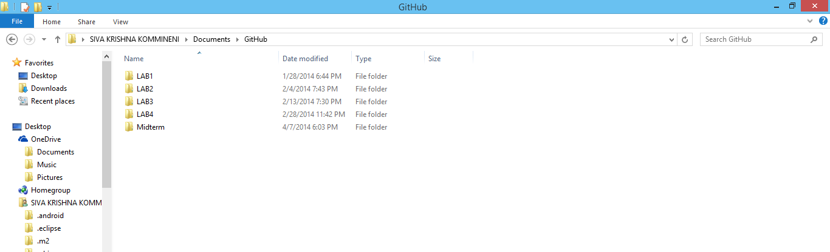

We can create the repositories by clicking own the create repositories buttion and specify the acess levels also.

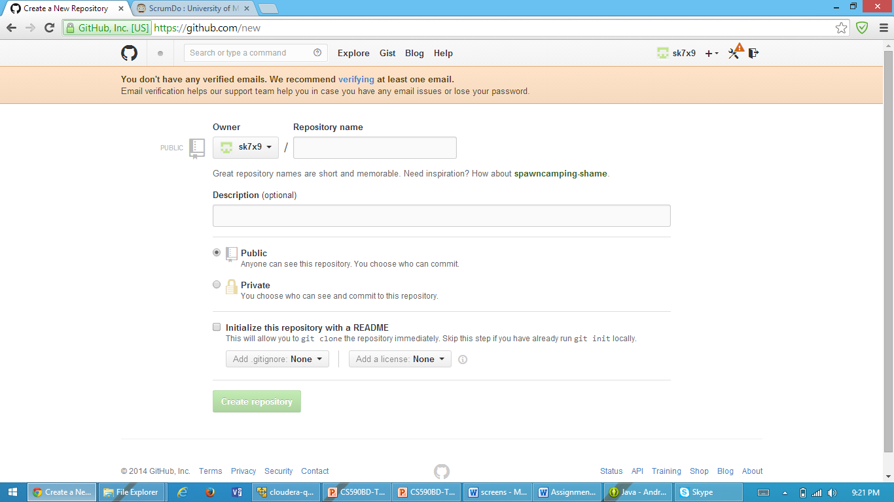

Later after synchronizing and committing the changes from the cloned path from desktop you can see the documents under created repositories as follows.

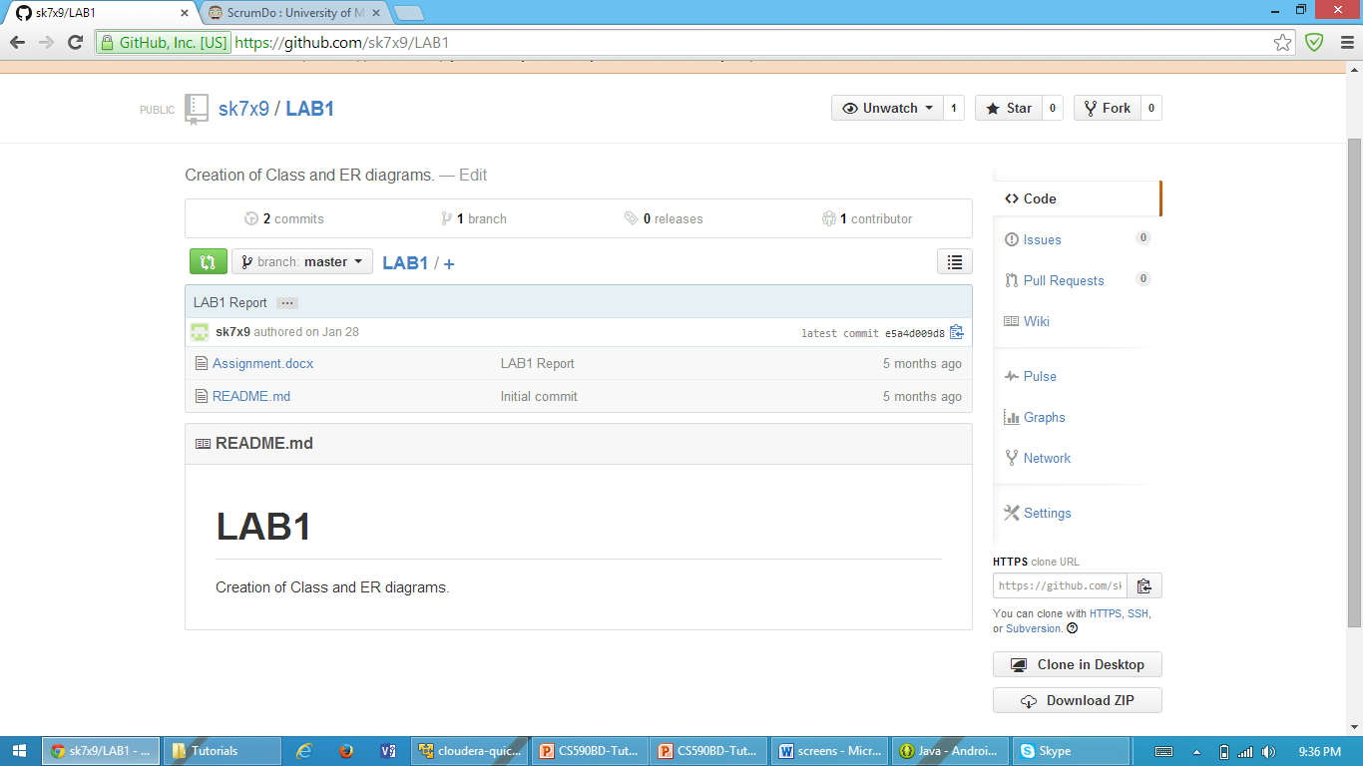

**Subtask 2:** How to create an account and design projects with Scrumdo

Next we need to set up a scrumdo account

Got to the following url <http://www.scrumdo.com>

If you are a new user set up your login information (or) else you can directly login.

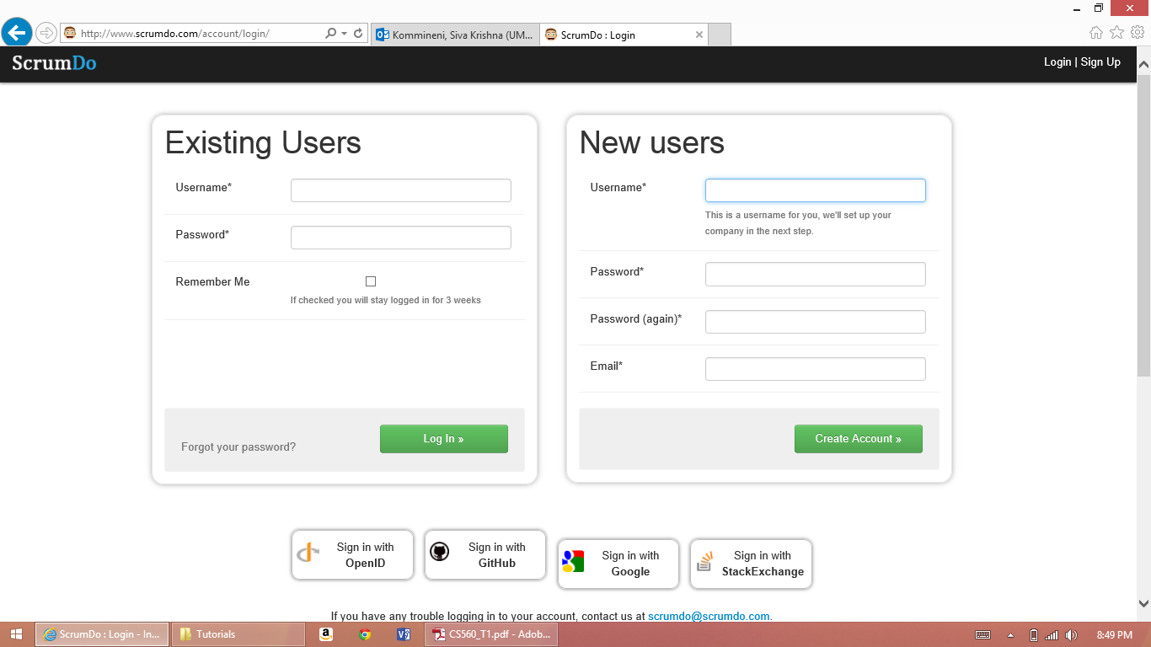

Complete the form and click on Create Account

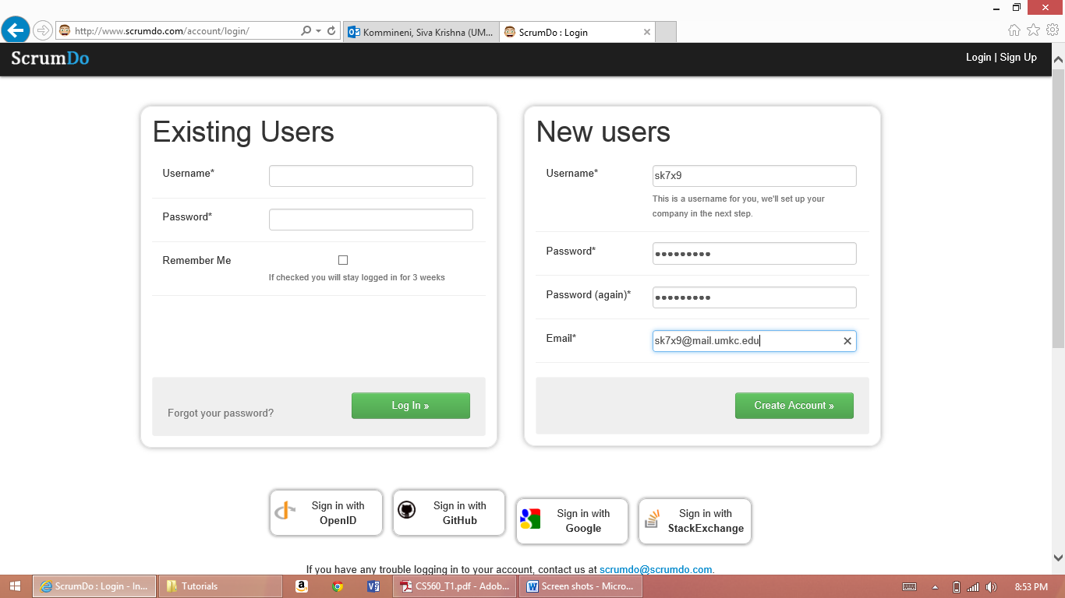

You will be directed to a page as follows after successful creation of your account.

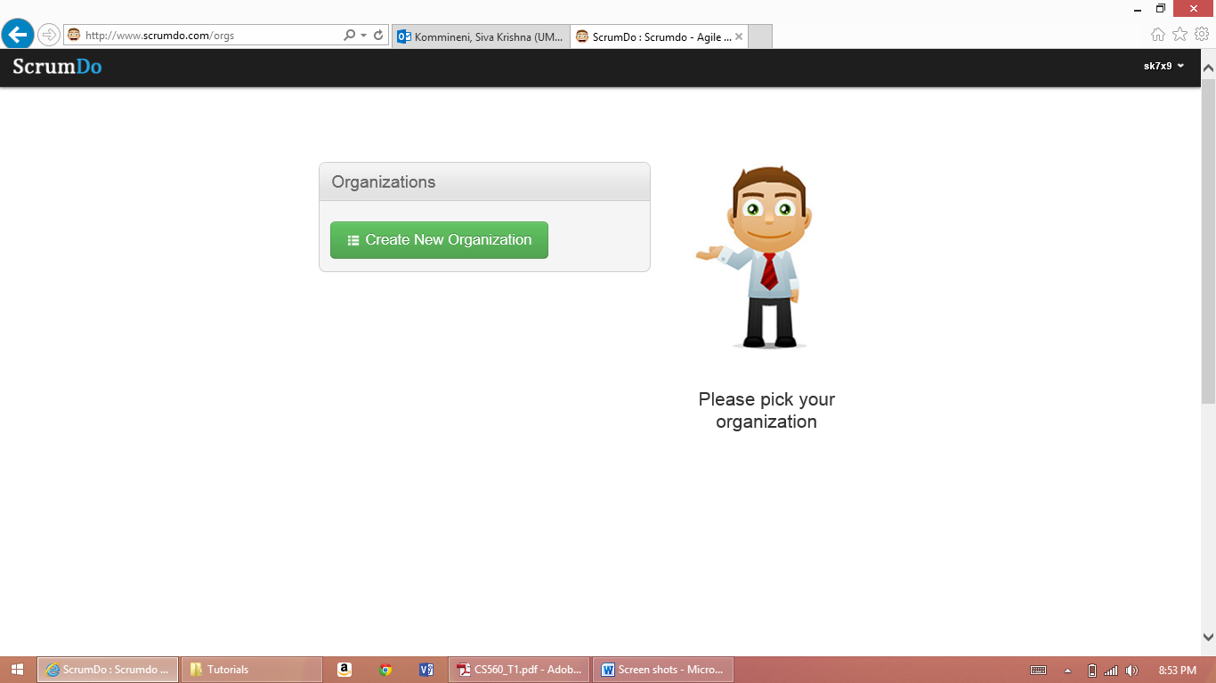

Next Create Iteration and add a user story to it as follows.

You can create stories and add tasks and assign them to the members.

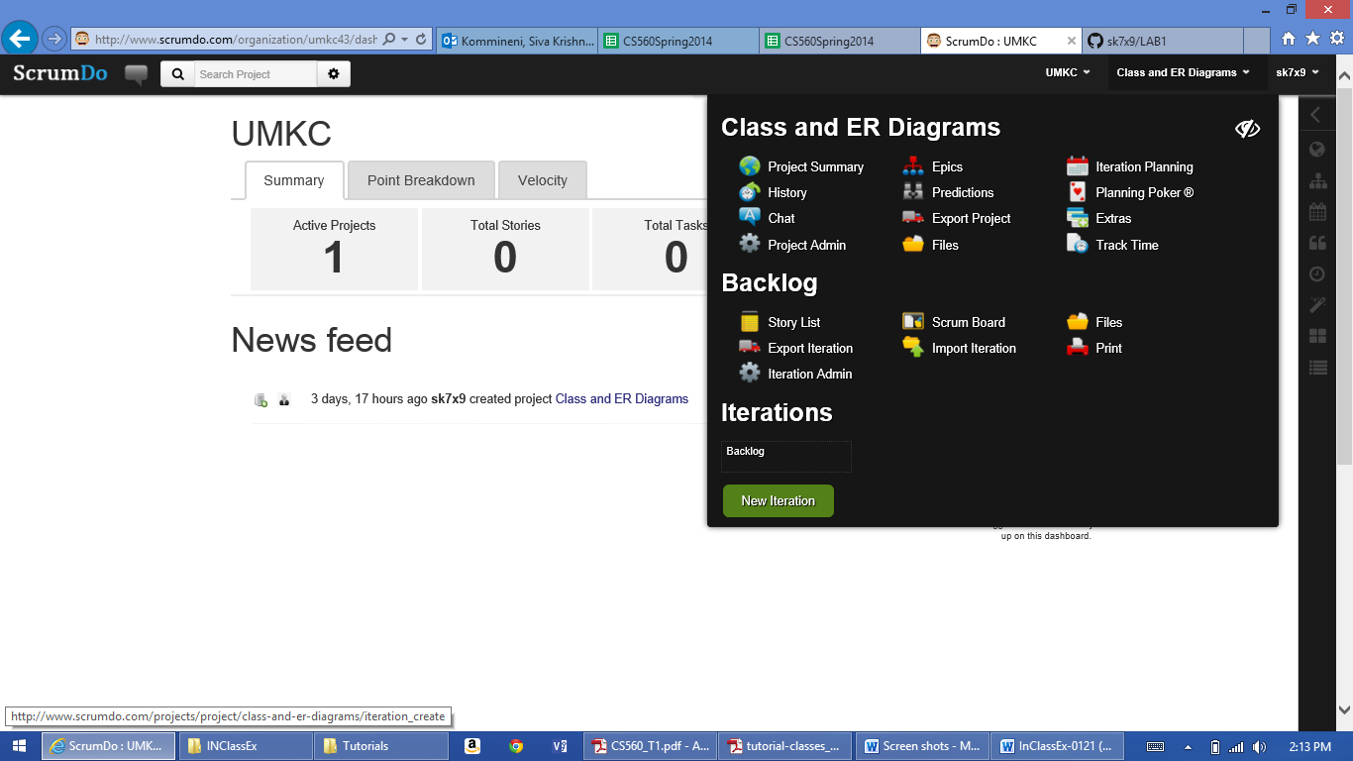

Iteration planning can be done and plan them accordingly.

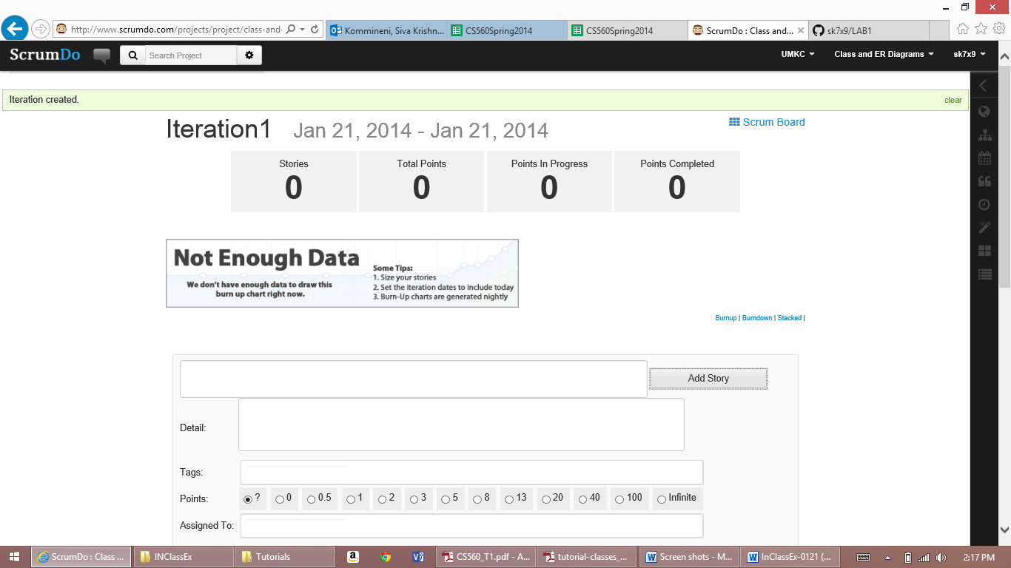

After creation of this add points then you can proceed through various stages as follows in the iteration.

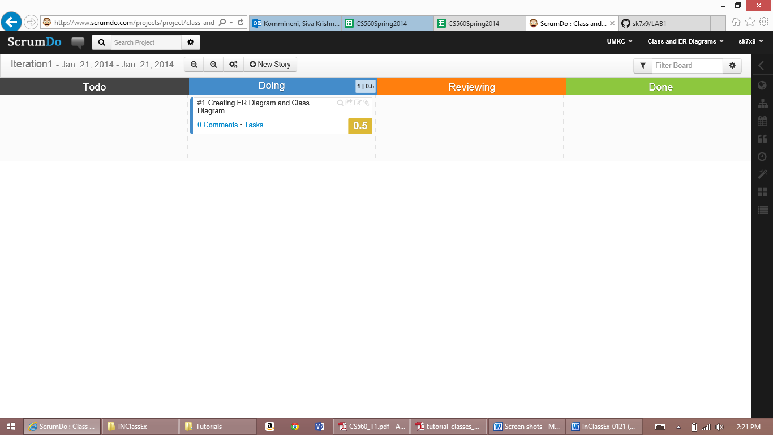

The tasks can be changed from various stages like Todo – Doing – Reviewing – Done

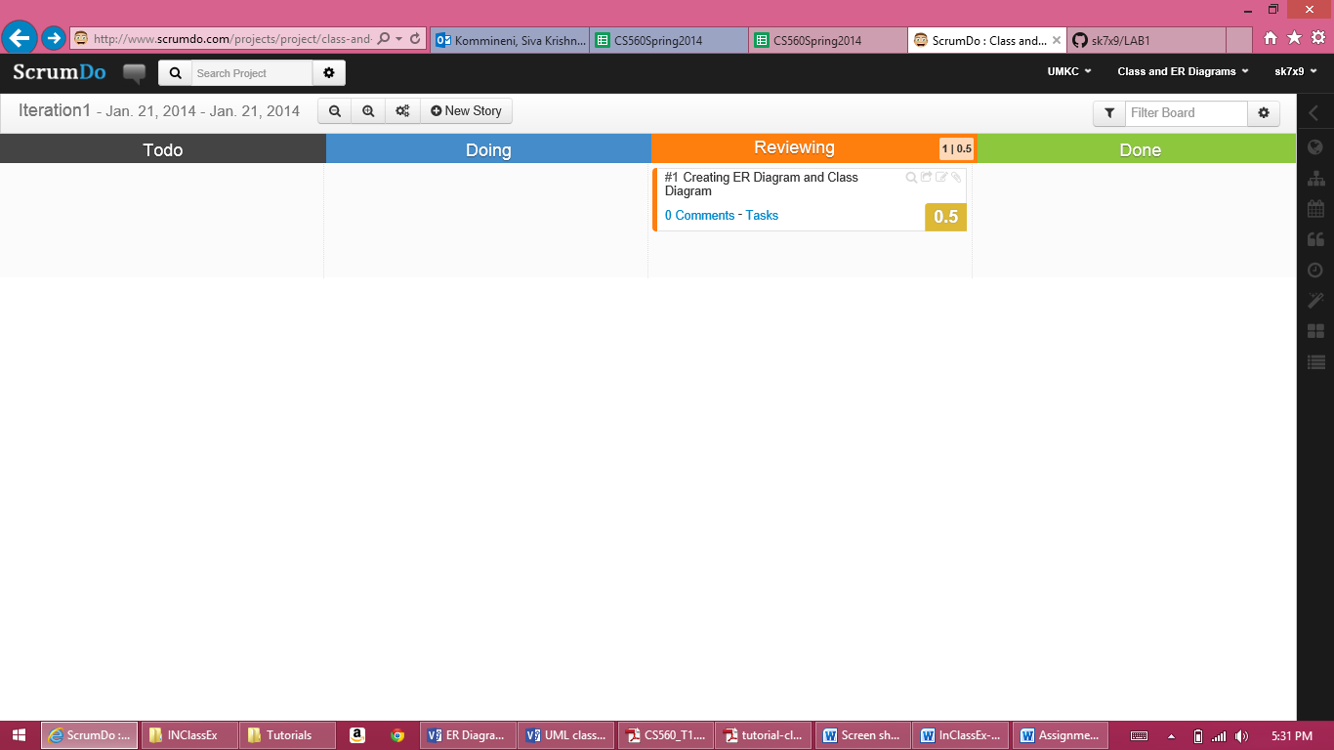

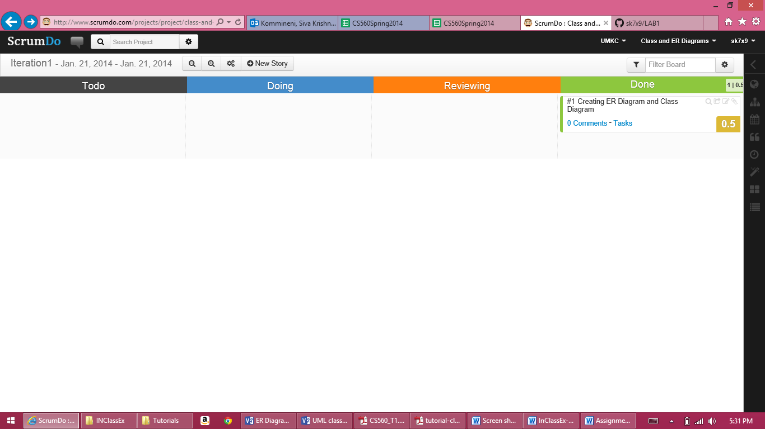

Finally after completion of all the tasks you can see the list on the dash board as completed stories and points earned as follows.

